1. **Questions SQL Queries/Sample Results**

Q1: How many single vs multiple-functions rooms were used last year in each of our resorts?

SELECT N_TimeYear_TI AS YEAR, T_RoomType_TR, C_ResortID_TR, SUM(N_TotalNumOfStays_TR) AS TotalStays, SUM(N_TotalPrice_TR) AS TotalProfit

FROM RoomTypeReservationsFact TR

JOIN TimeDim TI ON TR.C_TimeID_TR = TI.C_TimeID_TI

WHERE T_RoomType_TR IN ('SINGLE', 'MULTI') AND

N_TimeYear_TI = YEAR(DATE_SUB(CURDATE(), INTERVAL 1 YEAR))

GROUP BY T_RoomType_TR, C_ResortID_TR WITH ROLLUP;

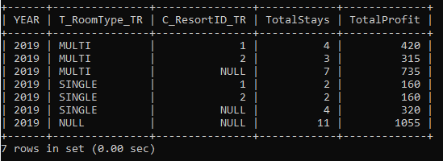

Q2: How many reservations have customers made with each of our resorts for a specific period i.e. last 2 years?

SELECT N_TimeYear_TI AS YEAR, C_ResortID_CR, COUNT(*) AS TotalReservations, SUM(N_TotalPrice_CR) AS TotalProfit

FROM CustomerReservationsFact CR

JOIN TimeDim TI ON CR.C_TimeID_CR = TI.C_TimeID_TI

WHERE N_TimeYear_TI >= YEAR(DATE_SUB(CURDATE(), INTERVAL 2 YEAR))

GROUP BY N_TimeYear_TI, C_ResortID_CR WITH ROLLUP;

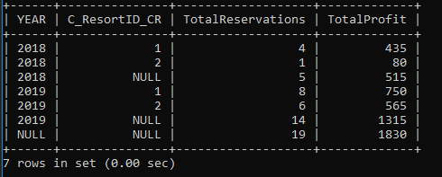

Q3: How many reservations were made because of events we hosted during a specific period vs another period i.e. 2018 vs 2019 at any of our resorts?

SELECT N_TimeYear_TI AS YEAR, C_EventID_ER, COUNT(*) AS TotalReservations, SUM(N_TotalPrice_ER) AS TotalProfit

FROM EventReservationsFact ER

JOIN TimeDim TI ON ER.C_TimeID_ER = TI.C_TimeID_TI

WHERE N_TimeYear_TI in ('2018', '2019')

GROUP BY N_TimeYear_TI, C_EventID_ER WITH ROLLUP;

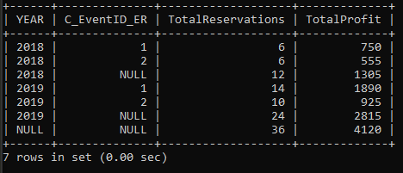

**2. Data Visualization (Created by ubiq)**

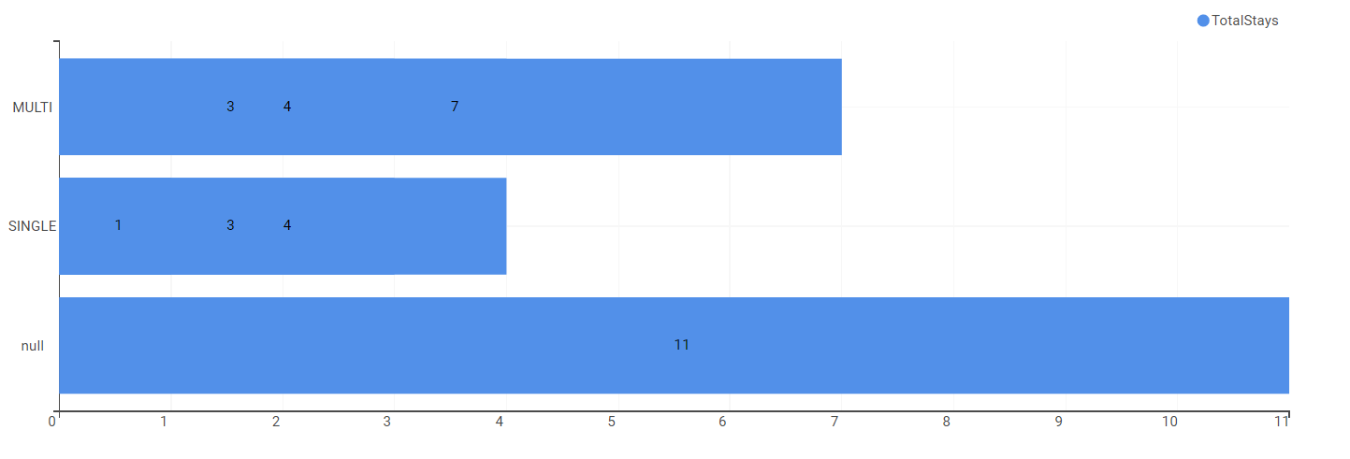**a. Q1**

Single vs Multiple-functions total stays for each resort in 2019

**b. Q2**

Total number of reservations in 2018 vs 2019 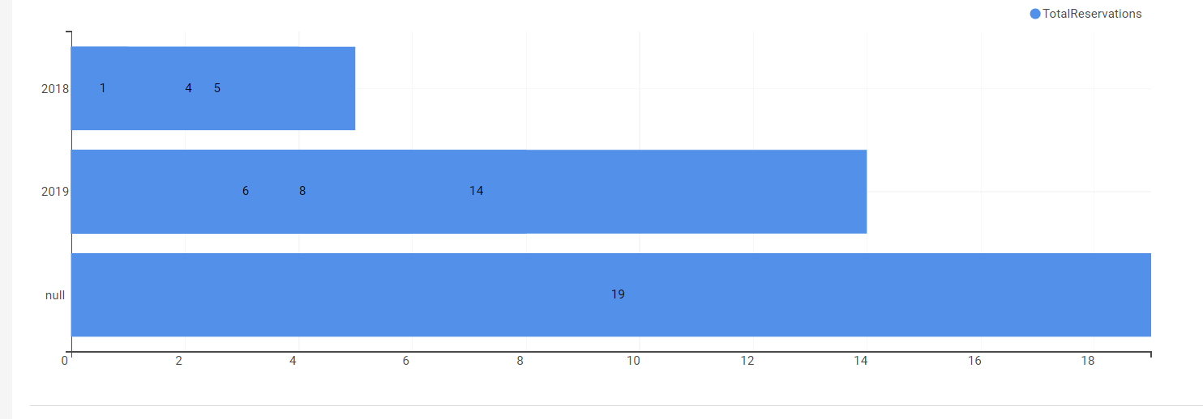

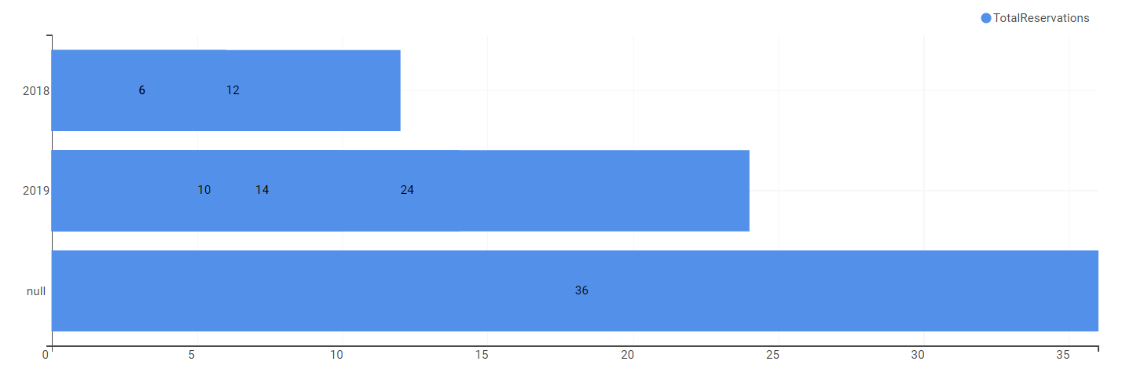**c. Q3**

Total number of reservations for events in 2018 vs 2019